

Android practicum part 5

# Introduction

Another addition is the use of the Android hardware.

How can you read the GPS position?

Good luck.

# Not yet another Copy

For this week you can continue working last weeks project.

# Silent Criminal Alert

Every criminal has a lastKnowLocation. By using the GPS we can measure if we are close to the bad guy.

When you are in range of thebad guy (within 100 meters) you can let your phone vibrate (S.C.A = Silent Criminal Alert)

## S.C.A. : On

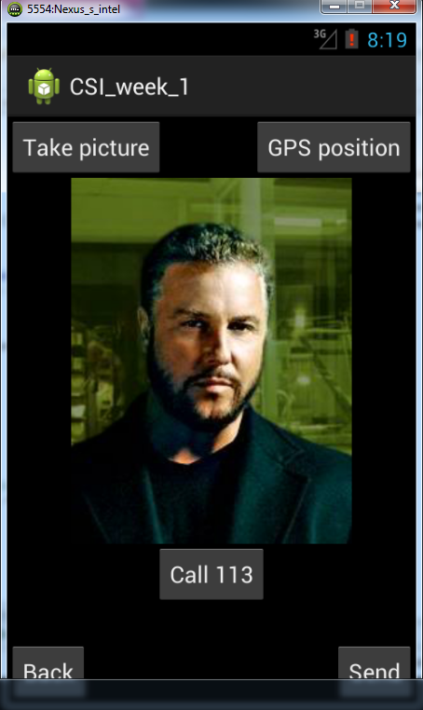

* Make adjustments to the above activity to turn SCA on/off (for instance add ‘SCA ON’ and ‘SCA OFF’ buttons).
* Create a LocationManager and let it sent updates when the location has been changed. Use the ‘requestLocationUpdates’ method of the LocationManager and set [GPS\_PROVIDER](http://developer.android.com/reference/android/location/LocationManager.html" \l "GPS_PROVIDER) as the provider, and provide your own version of a ‘LocationListener’.
* Calculate the difference between the found location that the locationListener receives and the lasknownPosition of the criminal.

(Hint: Check the documentation of the Location class. Maybe it can help you doing so)

* If the difference is less than 100 meter you can use the [Vibrator](http://developer.android.com/reference/android/os/Vibrator.html) class to let the phone vibrate. You can create your own pattern like so:

long[] pattern = new long[] { 20, 50, 100, 200, 40, 100 } ;

The pattern can be played by using the ‘vibrate(long[] pattern, int repeat)’ method.

## S.C.A. : Off

When we leave the activity, and SCA is still on, we don’t want to keep receiving location updates.

You can stop receiving the updates by calling ‘removeUpdates’ on the [LocationManager](http://developer.android.com/reference/android/location/LocationManager.html). Make sure that use use the same LocationListener that you previously used with requestLocationUpdates’.

Determine in which @override of the Activity code you can do this.

(onDestroy, onStop, onPause)

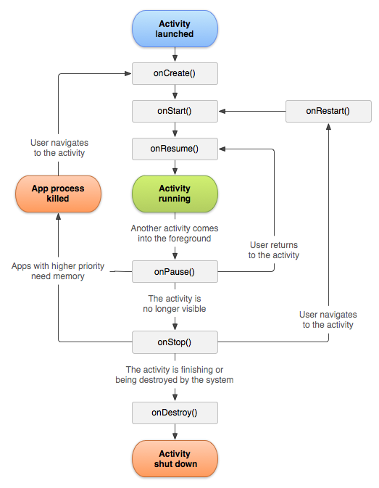

Figuur: [Activity](http://developer.android.com/reference/android/app/Activity.html) life cycle.

Where in the Activity lifecycle can you best start with ‘requestLocationUpdates’? Why? (onCreate, onStart, onResume?)

**Tip:** You can fake the GPS position in the emulator by switching to

DDMS view. Here you can set the position. More information on using the “Android Device Monitor” can be found here: <http://developer.android.com/tools/debugging/ddms.html>.

